RAFID FIRE DRAFT

MAX PERCENTAGE INCREASE 25%

Who am I? / WORD SCRAMBLE ( 5 QUESTIONS)

15 SEC (5%, 1% INCREASE FOR EACH QUESTION)

The more you take away from me the bigger I shall get. What am I ?

ANS: HOLE

It residential skyscraper in [Dubai](https://en.wikipedia.org/wiki/Dubai), [United Arab Emirates](https://en.wikipedia.org/wiki/United_Arab_Emirates). It was the world's tallest all-residential building until the completion of the nearby [Princess Tower](https://en.wikipedia.org/wiki/Princess_Tower).The tower has 57 swimming pools and each duplex in the tower is equipped with its own private elevator.

3 2 A M I N A R

Ans) 23 Marina

Solve the picture clue : ( 1 QUESTION)

20 sec

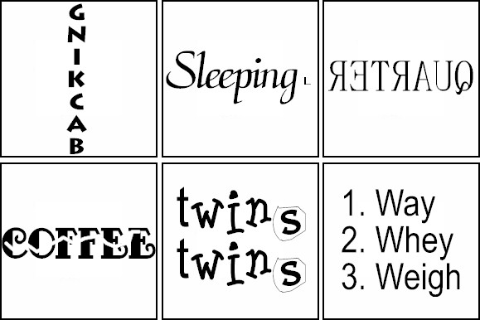

ANSWER : COFFEE BREAK

GUESS THE LOGO : ( 5 QUESTIONS )

20 SEC PER LOGO ( 1% Increase per question)



ANS: NASA

GUESS THE MONUMENT ( 5 QUESTIONS )

MONUMENTS ( 15 SEC) (5%)

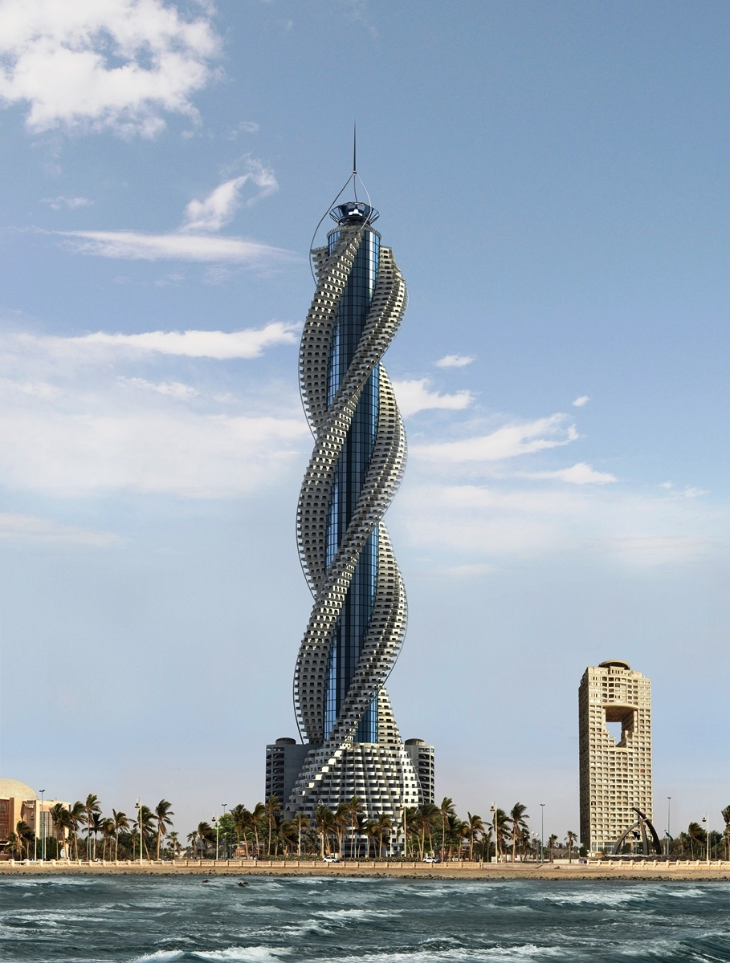

Ans : diamond tower

JIG SAW ( 1 QUESTION)

JIGSAW PUZZLE ( MIN NO OF MOVES +15 MOVES ) (5%) OR ON TIME

